Pin Mapping
MCU Pin | Pin Mode | Functional Description
PC8 | GPIO_Input | Detects state of window 1.
PC9 | GPIO_Input | Detects state of window 2.
PB2 | GPIO_Input | Detects state of window 3.
PB1 | GPIO_Input | Detects state of window 4.
PC3 | GPIO_Input | Detects state of door 1.
PA4 | GPIO_Input | Detects state of door 2.
PC11 | GPIO_Output | Toggles window 1 Arm Led
PC12 | GPIO_Output | Toggles window 1 Disarm Led
PB4 | GPIO_Output | Toggles window 2 Arm Led
PB5 | GPIO_Output | Toggles window 2 Disarm Led
PB8 | GPIO_Output | Toggles window 3 Arm Led
PB9 | GPIO_Output | Toggles window 3 Disarm Led
PC0 | GPIO_Output | Toggles window 4 Arm Led
PC1 | GPIO_Output | Toggles window 4 Disarm Led
PA1 | GPIO_Output | Toggles door 1 Arm Led
PA0 | GPIO_Output | Toggles door 1 Disarm Led
PA7 | GPIO_Output | Toggles door 2 Arm Led
PA6 | GPIO_Output | Toggles door 2 Disarm Led
PC2 | GPIO_Output | Toggles system Alarm
PB6 | TIM4_CH1 | Triggers interrupt on rising and falling edge of distance sensor 1
PB7 | TIM4_CH2 | Triggers interrupt on rising and falling edge of distance sensor 2
PA10 | GPIO_Output | Voltage level for keyboard column 1
PA11 | GPIO_Output | Voltage level for keyboard column 2
PA12 | GPIO_Output | Voltage level for keyboard column 3
PB12 | GPIO_EXTI12 | Triggers interrupt on row 1 press
PB13 | GPIO_EXTI13 | Triggers interrupt on row 2 press
PB14 | GPIO_EXTI14 | Triggers interrupt on row 3 press
PB15 | GPIO_EXTI15 | Triggers interrupt on row 4 press
PC4 | GPIO_Output | Toggles front door light
PC5 | GPIO_Output | Toggles back door light
PC6 | USART6_TX | Transmitter to LCD.
PC7 | USART6_RX | Receiver from virtual terminal
PA15 | TIM2_CH1 | Pulse for polling distance sensor 1
PB10 | TIM2_CH3 | Pulse for polling distance sensor 2
PB0 | GPIO_Output | Toggles buzzer.

MCU Resources
MCU Resource | Functional Description
USART6 | Communicates with devices that follow UART standard such as LCD and Virtual Terminal.
TIM2 | Generates pulses to poll the distance sensors.
TIM4 | Generates interrupts on rising and falling edges of distance sensor echos.
TIM10 | Generates an interrupt every second to increment the clock and also check for activation delay.
GPIO | Interfaces with any device that simply needs an on/off signal to operate.

Test Cases

{Sensor Leds/Open-Close sensors}

Will change sensor status via virtual terminal and show that it updates the LEDs in order to prove functionality. (Red = Alarm, Blue = Arm, Green = Disarm). Then open one of the sensors when armed to demonstrate alarm led. (Must type slow in virtual terminal since proteus is so slow)
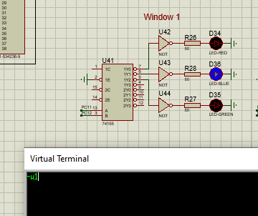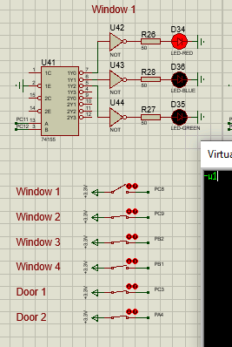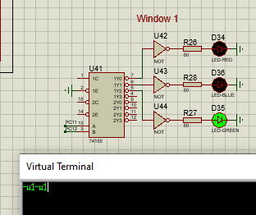
We can then see the system indicator flashing when system is in alarm state:
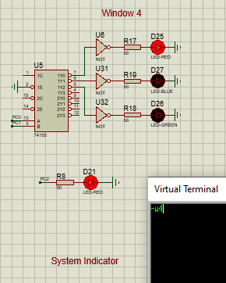

{LCD}

Will change sensor status via virtual terminal and show that it updates the LCD in order to prove functionality.
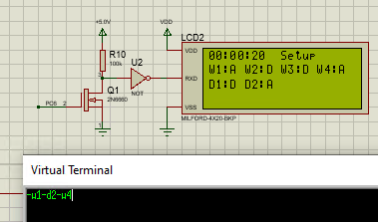

{Keyboard}

Will type in password to put system in disarmed or alarm state to prove functionality.
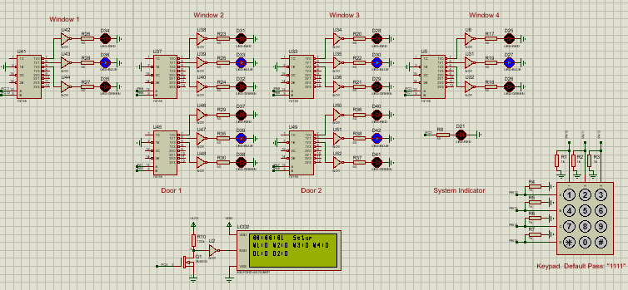

{Buzzer}

Will put system in alarm state to prove functionality.
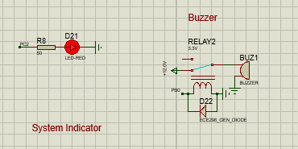

{Distance Sensor/Door Lights}

Once able to get this to work as MCU would sink echo voltage from the distance sensor. We could try a comparator to remedy the issue but simply ran out of time.
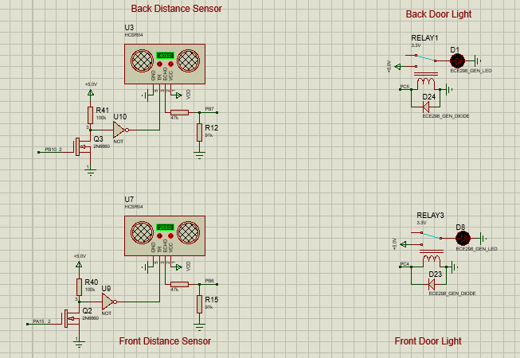

{Virtual Terminal}

Functionality was proven via the previous examples.

